# 

**MiniProject-1**

DEPARTMENT OF COMPUTER APPLICATION

BCA-2024

SEMESTER-3

FRONT END WEB DEVELOPMENT

Topic: Employee Details

Mentor Name : Veera Raghav K

Done by: Muhammed Faiz C K

Reg No: 2411021240042

Mentor Signature:_______

# Report on Employee Login Details Webpage

## Introduction

The Employee Login Details webpage is a simple HTML and JavaScript-based form designed to collect basic employee information for login and feedback purposes. It utilizes modern styling with CSS to ensure user-friendliness and professional appearance.

## Webpage Structure

The webpage consists of the following main components:

1. A structured form inside a centered container with styling for better user experience.

2. Input fields for capturing essential employee information such as ID, name, company, email, phone, and password.

3. A feedback textarea field for employee input.

4. A styled button that triggers a JavaScript alert message upon login.

## HTML Form Elements

The form includes the following fields:

- Employee ID (Text input)

- First Name (Text input)

- Last Name (Text input)

- Company (Text input)

- Email ID (Email input)

- Phone Number (Telephone input)

- Password (Password input with hidden characters)

- Feedback (Multiline textarea)

## Styling (CSS)

The page uses inline CSS to style the body, form container, headings, labels, inputs, textarea, and button. The container is centered with padding, rounded corners, and a subtle shadow for modern aesthetics. The button has hover effects to improve interactivity.

## Output Code & Screenshots

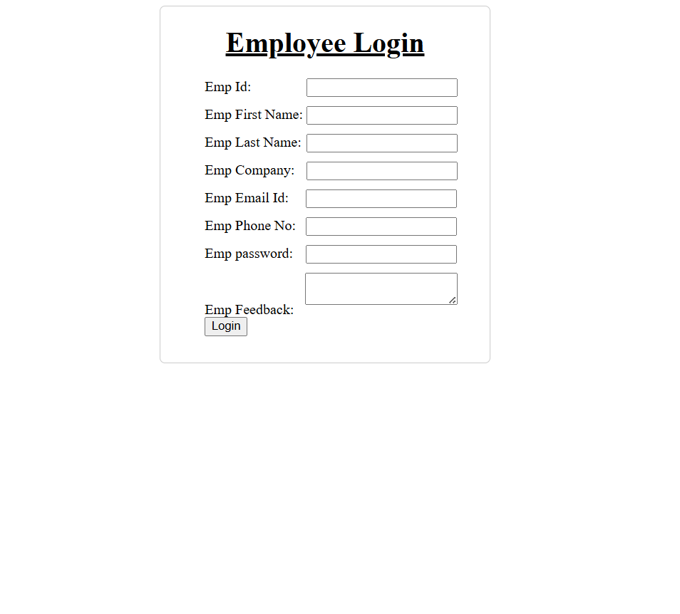

## JavaScript Functionality

A simple JavaScript function `Btn()` is included, which is triggered when the user clicks the 'Log In' button. It displays a browser alert box with the message 'Login Successfully !!!'. This indicates form submission but does not yet store or validate the data.

## Conclusion

The Employee Login Details webpage provides a clean and functional interface for collecting basic employee information. It demonstrates fundamental use of HTML forms, CSS styling, and JavaScript interactivity. For real-world applications, additional features such as input validation, secure password handling, and backend integration would be necessary.